SRI SIDDHARTHA ACADEMY OF HIGHER EDUCATION
(Declared as Deemed to be University Under Section 3 of the UGC Act, 1956, Accredited by NAAC ‘A+’ Grade)
AGALKOTE, TUMAKURU – 572107
KARNATAKA



Technical Seminar (22ECTS707) Synopsis
on
“TITLE”

Submitted by
STUDENT NAME | (USN)

In partial fulfillment of requirements for the award of degree

BACHELOR OF ENGINEERING
IN
ELECTRONICS AND COMMUNICATION ENGINEERING
(Accredited by NBA)

Under the guidance of
GUIDE NAME (qualification)
Designation, Dept. of ECE,

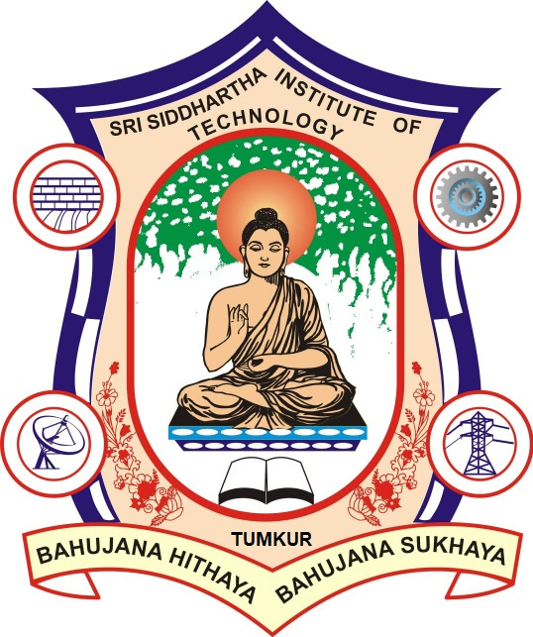

SRI SIDDHARTHA INSTITUTE OF TECHNOLOGY
(A Constituent College of Sri Siddhartha Academy of Higher Education Tumakuru, Approved by AICTE)
MARALUR, TUMAKURU-572105

2025-2026

Technical Seminar (22ECTS707)

Synopsis
on
“TITLE”
Introduction to technical seminar topic and brief methodology should be submitted by students.

REFERENCES
- D. K. Aagri and A. Bisht, "Export and Import of Renewable energy by Hybrid MicroGrid via IoT," 2018 3rd International Conference On Internet of Things: Smart Innovation and Usages (IoT-SIU), 2018, pp. 1-4, doi: 10.1109/IoT-SIU.2018.8519873.
- S. Sharma, S. Das, J. Virmani, M. Sharma, S. Singh and A. Das, "IoT Based Dipstick Type Engine Oil Level and Impurities Monitoring System: A Portable Online Spectrophotometer," 2019 4th International Conference on Internet of Things: Smart Innovation and Usages (IoT-SIU), 2019, pp. 1-4, doi: 10.1109/IoT-SIU.2019.8777703.

Minimum of 10 References (Preferably IEEE conference/transaction) should be incorporated in reference section.

Note: 1. Use transparent sheet for submission of Synopsis

